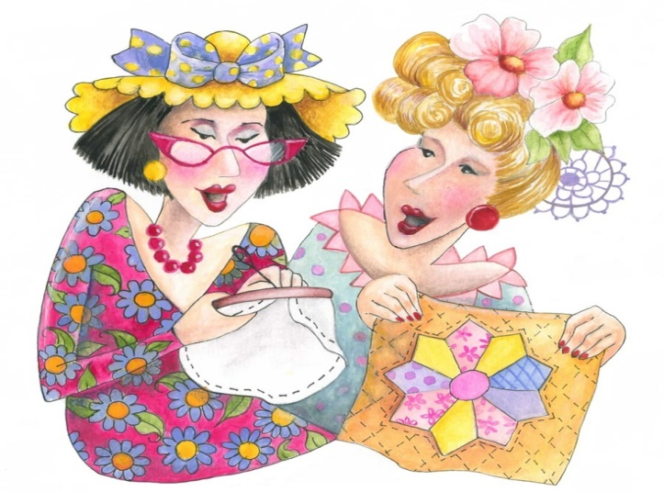
American Quilter’s Society Bus Trip 2022
The Kalona Historical Village Quilt and Textile Museum is inviting you to join us for our bus trip to the American Quilter’s Society Show Wednesday September 14, 2022 in Des Moines.
Join Nancy for a fun day trip! We will meet at the Kalona Historical Village Visitor Center- 715 D Ave, and depart at 7:30 AM to travel to Des Moines. We will also be picking up at Barnes & Noble in Coralville at approximately 8 AM and VF Wrangler at the outlet mall in Williamsburg at approximately 8:30, just make a note below if you need to be picked up at either of these locations. We will serve coffee, juice, and strudel on the bus. You will be on your own for lunch, but we will have a wonderful dinner waiting for us at 5 PM at the Machine Shed before we travel back home.
Cost for the trip will be $125. This includes: breakfast of strudel, juice, and coffee, the bus ride, entry into the quilt show, dinner, and gratuities to the Driver.
Reservations are on a first come basis only. Full payment must be received with the reservation to guarantee your space. If cancellation notice is not received within 5 days of the trip, full payment loss will result (unless a replacement can be found). The Kalona Historical Village reserves the right to cancel this trip with a full refund to you if sufficient level of participation can’t be reached. I must have a minimum of 30 people to make the trip so invite a friend (or two!) to come along with you.
Please send reservations before Wednesday, August 31st, 2022-remember this is first come, first serve.
Nancy Roth
715 D Ave
Kalona, IA 52247
319-656-3232 or email kalonatours@gmail.com
---------------------------------------------------------------------------------------------------------------------
American Quilter’s Society Show Reservations 2022
Name:________________________________________________________________
Address:______________________________________________________________
Phone Number:________________________________________________________
Number of people attending:________ Pick up at:____________________________
Money enclosed:___________________________
E-mail:________________________________________________________________

