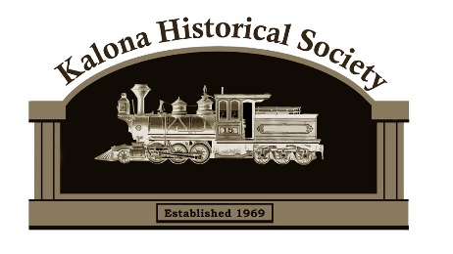
The Kalona Historical Society promotes the history and culture of our area by educating the public on the value of preservation and interpretation.

The Kalona Historical Society Museum and Village has grown from the saving of the Depot in 1969 to a facility featuring 12 historical buildings, a collection of over 700 quilts and a modern visitor’s center to house those quilts, displays and artifacts relevant to the history of Kalona.
The museum draws over 6,000 visitors a year from all 50 states and 50 countries and is one of the leading tourist attractions in Eastern Iowa. We are very proud of this but at the same time we are always looking for ways to serve and to be relevant to the Kalona area and its citizens. We are building our school group program every year, this program helps local and non-local social studies programs focus on history thru our exhibits meeting their core curriculum.
The museum hosts several community events every year including Fall Festival, Easter egg hunt, golf benefit, soup supper, and much more. We are very grateful to all the local businesses that help sponsor these events through the years.
Our Business Membership program gives businesses the opportunity to continue supporting these events and also receive other benefits for their business and employees.
Please review the membership levels and benefits of each and consider becoming a business member at the level that best suits your business. Events that you sponsor will help purchase supplies for the event, your business will be recognized at each. If you have any questions please call the Village 319-656-3232 or e-mail us kalonatours@gmail.com. Thank you for your time and consideration!
BENEFITS | Leader  $1500 | Supporter  $750 | Donor  $500
Customized “Sunday Funday” at Kalona Historical Village for employees and families | X  $200
Coupons for free admission to Kalona Historical Village | 50  $500 | 30  $300 | 20  $200
Invitation to private “Opening Day” at the Village. | 10  $100 | 5  $50 | 5  $50
Featured article highlighting history of your business in KHS newsletter | X | X | X
Subscription to KHS newsletter – four editions | X | X | X
Listing on website under Supporter section with logo and link to website | X | X | X
Sponsorship recognition at KHS events. (choose from the list on right) | 5 events  $750 | 2 events  $300 | 1 event  $150
Summer Camp Scholarships ($100 per camper) | X  $300 | X  $200 | X  $100
BUSINESS MEMBERSHIP

Sponsor Events:
1. Drive thru Soup Supper-Held in March
2. Easter Egg Hunt-Held in April (family based)
3. Speaker Event- Throughout the year
4. Golf Benefit-Held in June
5. Fall Festival-Held in September (50th Anniversary this year!)
6. “Beyond the Grave” Cemetery Walk-Held in October
7. Jack O’ Lantern Jaunt-Held in October
(family based)

Membership Level Selected
______Leader - $1500
______Supporter - $750
______Donor - $500

How would you like to receive your quarterly Newsletter:___Mail ___E-Mail

Business Name:_______________________________________________
Contact Name:________________________________________________
Address:_____________________________________________________
City:_________________________State:__________Zip:_____________
Phone:_____________________ E-Mail:___________________________
Please make checks payable to Kalona Historical Society

